# Sprint – 4 Export the Analytics

**Team ID:** PNT2022TMID42593

**Project Name:** Estimate the Crop Yield Using Data Analytics

Exporting The Analytics:

1. **After Creating Dashboard Export the Analytics:**

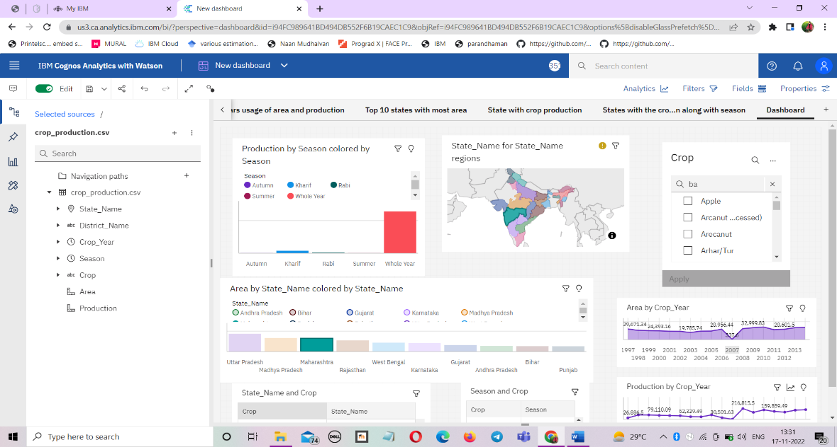

1. **Click icon share to Share & Export to PDF**

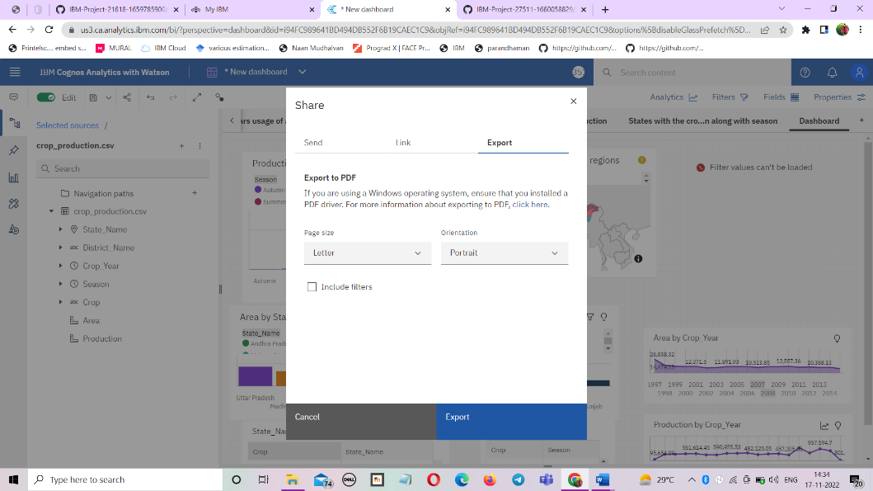

Building Pdf format

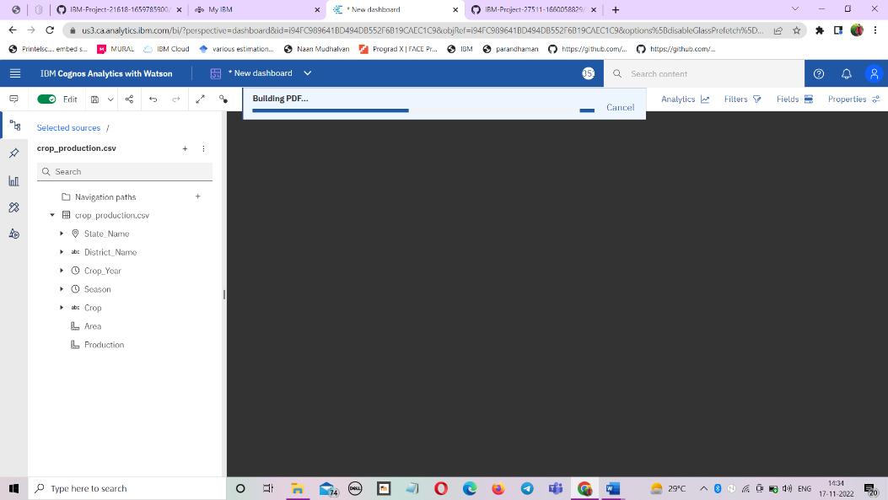

# Preview the Pdf pages to print or download

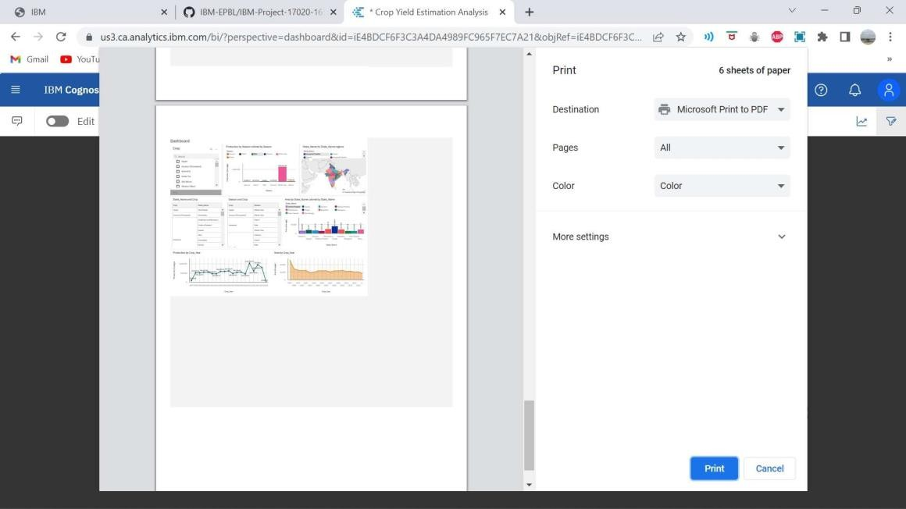

Click Print & Save The Exported Analytics as PDF file.